ONE TO ONE AND MANY TO MANY

Q1. Consider the following entities and their relationships. Create a

RDB in 3 NF with appropriate data types and Constraints. [15 Marks]

Patient (PCode, Name, Addr, Disease)

Bed (Bed_No, RoomNo, loc)

Relationship: - There is one-one relationship between patient and bed.

create table patient(pcode int primary key,name varchar(20) not null,addr varchar(20),disease varchar(10));

desc patient;

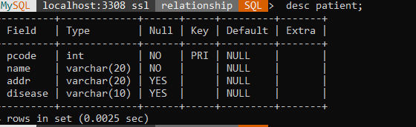

insert into patient values(11,'Raghav','pimple gurav','listeria');

insert into patient values(12,'Abhay','pune','norovirus');

insert into patient values(13,'Mr.Roy','mumbai','cholera');

insert into patient values(14,'Sachin','pimple gurav','dengue');

select * from patient;

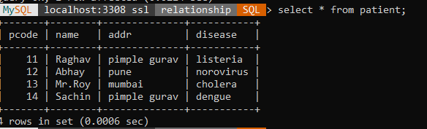

create table bed(bno int primary key,rno int not null,loc varchar(10) not null,pcode int references patient on delete cascade);

desc bed;

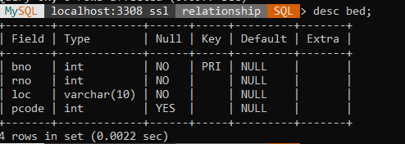

insert into bed values(1,105,'pune',11);

insert into bed values(2,102,'2nd floor',12);

insert into bed values(3,103,'4th floor',13);

insert into bed values(4,104,'1st floor',11);

select * from bed;

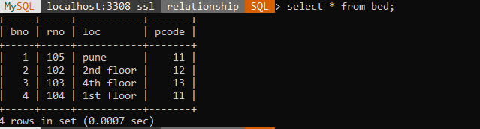

Display the details of patients who are from “Pimple Gurav”

select * from patient where addr='pimple gurav'; 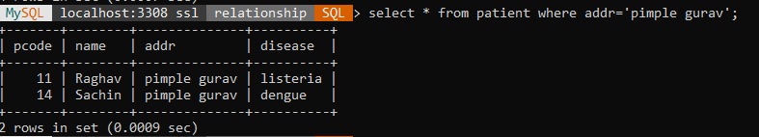

 Delete the details of patient whose Bed_No is 1 and RoomNo is 105.

select * from patient,bed where patient.pcode=bed.pcode and bno=1 and rno=105;

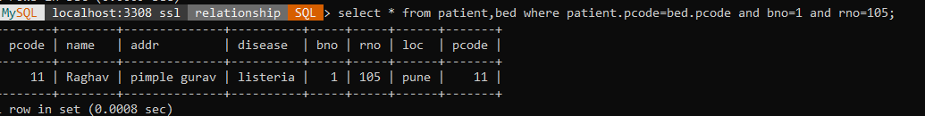

Display the count of patient room wise.

select count(patient.pcode) from patient,bed where patient.pcode=bed.pcode group by rno;

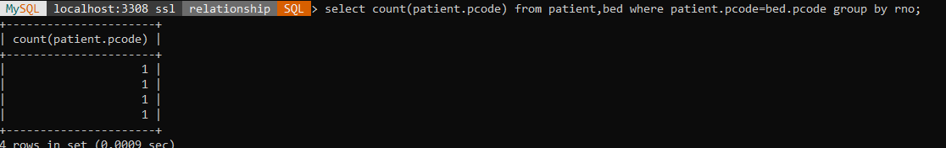

Display the names of patients who are admitted in room no 101.

select name from patient,bed where patient.pcode=bed.pcode and rno=102;

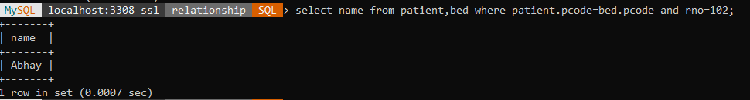

Display the disease of patient whose bed_No is 1

select disease from patient,bed where patient.pcode=bed.pcode and bno=1;

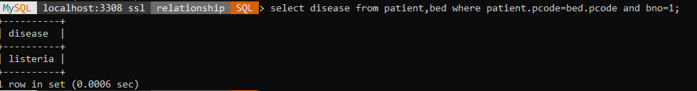

 Display the room_no and bed_no of patient whose name is “Mr Roy”

select rno,bno from patient,bed where patient.pcode=bed.pcode and name='Mr.Roy';

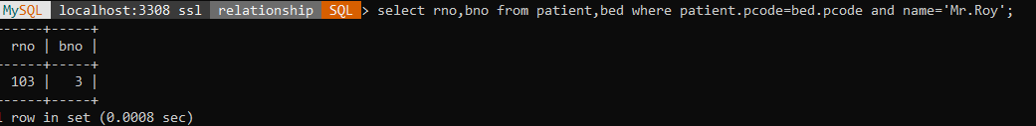

Give the details of Patient who is admitted on 2nd flr in roomno 102.

select * from patient,bed where patient.pcode=bed.pcode and loc='2nd floor' and rno=102;

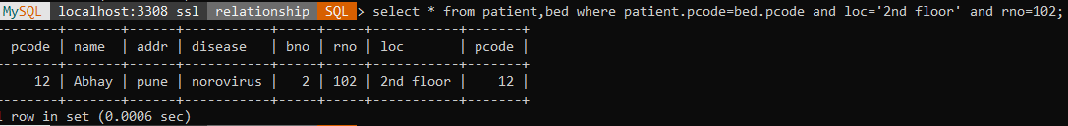

******************************************************************************************************************************

Q2. Q3. Consider the following entities and their relationships.

Create a RDB in 3 NF with appropriate data types and Constraints. [15 Marks]

Customer (cust_no, cust_name, address, city)

Loan (loan_no, loan_amt)

The relationship between Customer and Loan is Many to Many

create table customer(cno int primary key,cname varchar(20) not null,addr varchar(20),city varchar(10));

desc customer;

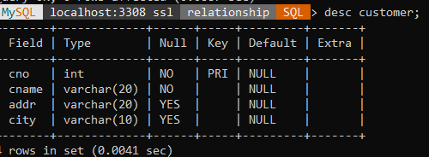

insert into customer values(101,'Dhiraj','kharadi','pune');

insert into customer values(102,'Patil','kalptaru','pimpri');

insert into customer values(103,'Abhay','west','pimpri');

insert into customer values(104,'Raghav','rt','nashik');

insert into customer values(105,'Dhanu','bvh','pune');

select * from customer;

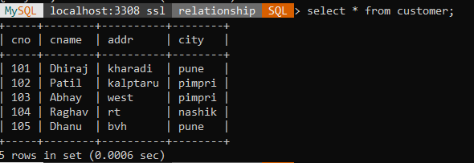

create table loan1(lno int primary key,lamt int check(lamt>0),cno int references customer (cno));

insert into loan values(1,120000,101);

insert into loan1 values(1,120000,101);

insert into loan1 values(2,100000,102);

insert into loan values(3,30000,103);

insert into loan1 values(3,30000,103);

insert into loan1 values(4,120,104);

insert into loan1 values(5,1000000,105);

select * from loan1;

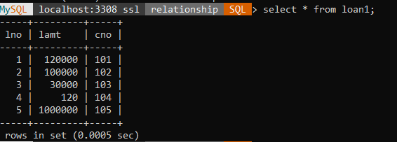

create table cust_loan(cno int references customer (cno),lno int references loan1(lno),loan_status varchar(20));

insert into cust_loan values(101,1,'I');

insert into cust_loan values(102,3,'C');

insert into cust_loan values(101,4,'P');

insert into cust_loan values(104,5,'I');

insert into cust_loan values(103,2,'C');

insert into cust_loan values(105,5,'C');

select * from cust_loan;

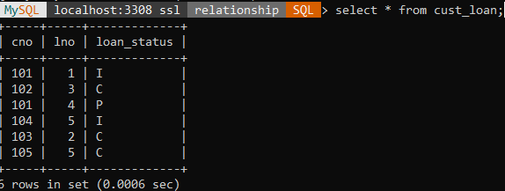

Add Phone_No column in customer table with data type int.

alter table customer add phone_no int;

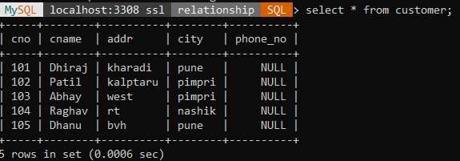

 Find details of all customers whose loan_amt is greater than 10 lack.

select * from customer,loan1 where customer.cno=loan1.cno and lamt>25000;

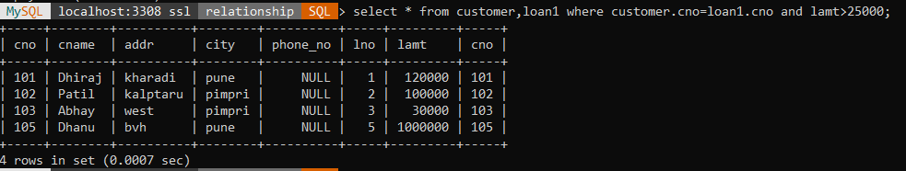

List all customers whose name starts with 'D' character.

select * from customer where cname like 'D%';

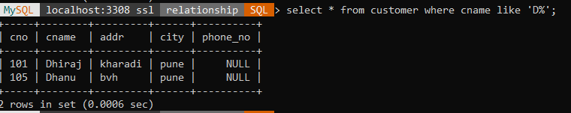

List the names of customer in descending order who has taken a loan from Pimpri city.

select * from customer where city='pimpri' order by cname desc;

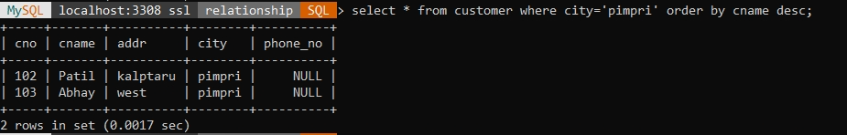

Display customer details having maximum loan amount

select max(lamt) from customer,loan1 where customer.cno=loan1.cno;

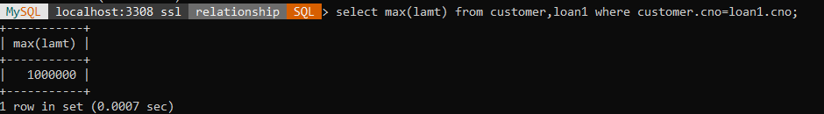

******************************************************************************************************************************

Q3. Consider the following entities and their relationships.

Create a RDB in 3 NF with appropriate data types and Constraints. [15 Marks]

Room (roomno, desc, rate)

Guest (gno, gname, no_of_days)

The relationship between Room and Guest is One to One. Constraint:

create table room(rno int primary key,des varchar(20),rate int);

insert into room values(101,'A/C',1500);

insert into room values(102,'Non A/C',750);

insert into room values(103,'A/C',2000);

insert into room values(104,'Non A/C',1200);

select * from room;

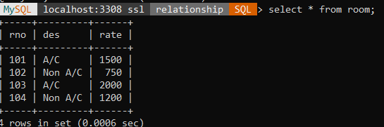

create table guestt(gno int primary key,gname varchar(20),nod int check (nod>0),rno int references room(rno));

insert into guestt values(101,'Mr.Bharat',3,101);

insert into guestt values(102,'Mr.Nilesh',4,102);

insert into guestt values(103,'Mr.Advait',7,104);

insert into guestt values(104,'Miss.Sapana',2,101);

select * from guestt;

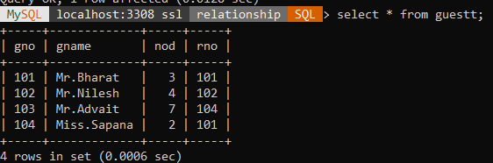

 Update the rate of room to 5000 whose type is “AC”

update room set rate=5000 where des='A/C';

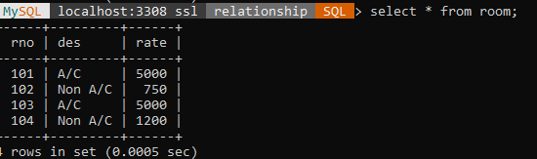

Display room details according to its rates in ascending order

select des,rate from room order by des asc;

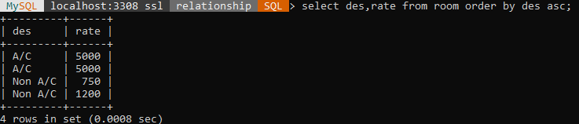

Find no. of AC rooms.

select count(rno) from room where des='A/C';

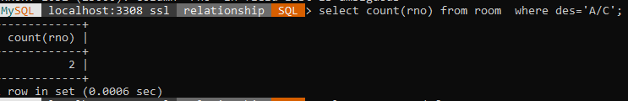

 Display guest wise halt days, Select gname,nod from guest

Select gname,nod from guest Order by gname;

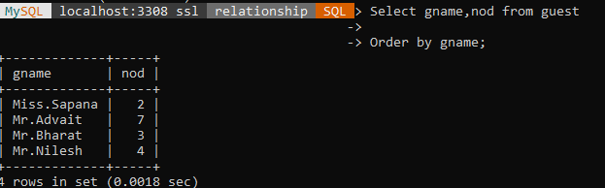

******************************************************************************************************************************

Q4. Consider the following entities and their relationships. Create a

RDB in 3 NF with appropriate data types and Constraints. [15 Marks]

Book (Book_no, title, author, price, year_published) Customer (cid, cname, addr)

Relation between Book and Customer is Many to Many with quantity as descriptive attribute. Constraint: Primary key, price should be >0;

create table book(bno int primary key,title varchar(10),author varchar(20), price int check(price>0),yp int);

insert into book values(101,'dreams','mr.Raj',150,2017);

insert into book values(102,'life','mr.Raghav',100,2019);

insert into book values(103,'rt story','mr.Gadhave',190,2011);

insert into book values(104,'Dad','dr.Sam',200,2001);

insert into book values(105,'Struggle','mr.Raj',250,2017);

select * from book;

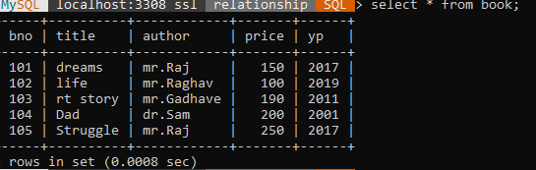

create table customerr(cid int primary key,cname varchar(20),addr varchar(20),bno int references book);

insert into customerr values(1,'Abhay','pune',101);

insert into customerr values(2,'Sam','Mumbai',102);

insert into customerr values(3,'Raghav','pimpri',103);

insert into customerr values(4,'Abhay','mumbai',104);

insert into customerr values(5,'Ganesh','Nashik',105);

select * from customerr;

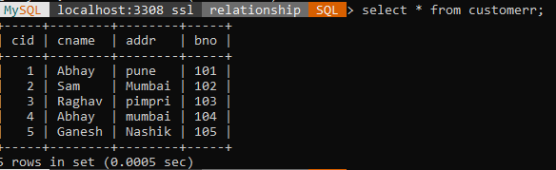

create table customerbook(bcid int primary key,bno int references book, cid int references customerr);

desc customerbook;

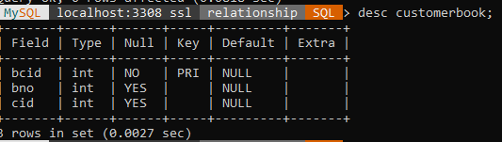

insert into customerbook values(11,101,1);

insert into customerbook values(12,102,2);

insert into customerbook values(13,101,3);

insert into customerbook values(14,103,1);

insert into customerbook values(15,106,4);

select * from customerbook;

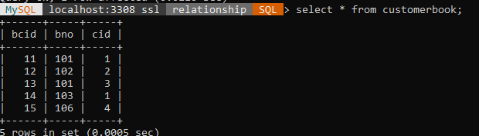

Display the name of book whose author is “Mr. Gadhave”.

select title from book where author='mr.Gadhave';

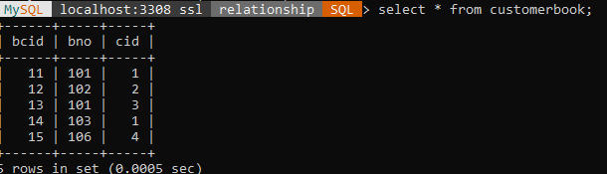

Add column EMailId into customer table.

alter table customerr add emailID varchar(20);

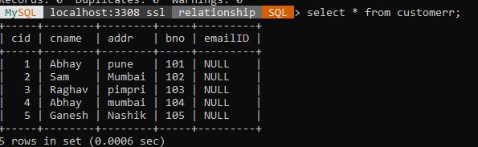

 Display customer details from 'Mumbai'.

select * from customerr where addr='mumbai';

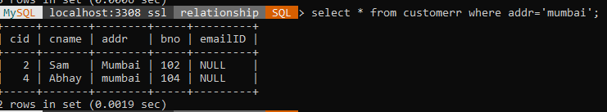

 Display author wise details of book.

select author,title from book order by author;

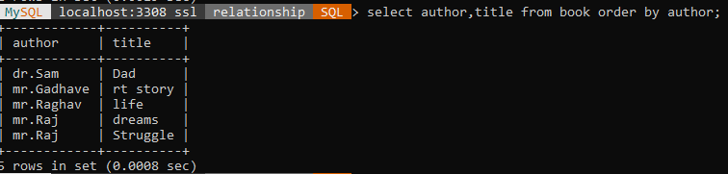

Display customer name that has purchased more than 3 books.

select count(book.bno),cname from customerr,book,customerbook where customerr.cid=customerbook.cid and book.bno=customerbook.bno and book.bno>3 group by cname;

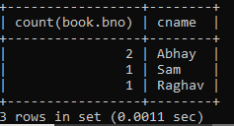

Display book names having price between 100 and 200 and published year is 2019.

select book.title from book,customerr,customerbook where customerr.cid=customerbook.cid and book.bno=customerbook.bno and yp=2019 and price between 100 and 200;



 Update the title of book to “DBMS” whose author is “mr.gadhave”.

update book set title='DBMS'where author='mr. Gadhave';

